21.69: a) 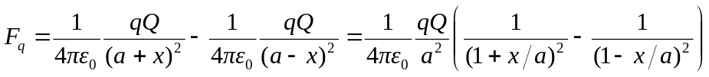
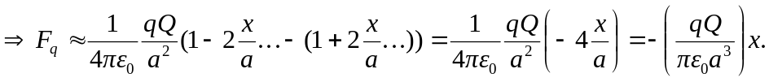 But this is the equation of a simple harmonic oscillator, so:
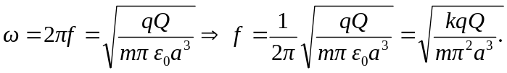
b) If the charge was placed on the y-axis there would be no restoring force if and had the same sign. It would move straight out from the origin along the y-axis, since the x-components of force would cancel.

